**EASY ATTENDANCE**

**Staff side:**

1. A window with Option to **Enter admin username and password**

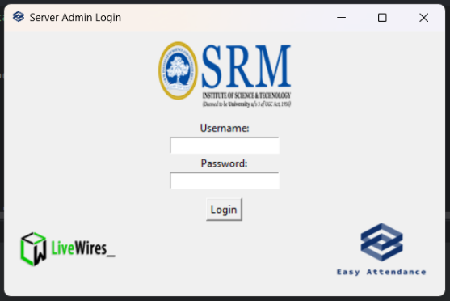

1. A new window (i.e.) **Staff_Entry_Ui** to select **staff in charge, subjects and class**
   * 1. if that staff have **only one Subject / Class**, it will be **auto selected**
     2. 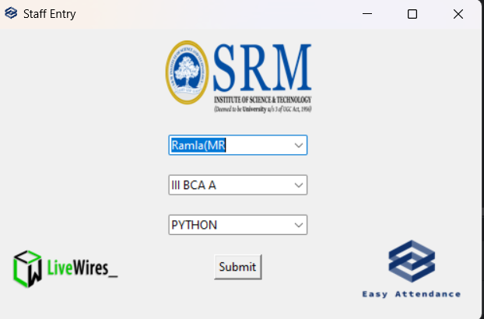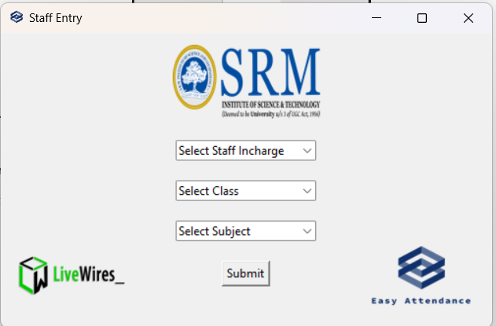Else they have to choose the particular Subject / Class
2. **Staff Entry Ui** will be **automatically** **called** for every period.

With Staff Entry Ui we get:

* + 1. Staff In charge Name
    2. Class Name and **with this we will search if the student is for this class or not**
    3. Subject handled by that staff

1. Staff has to Select the subject and submit it, then only Students will be able to update their attendance, Else they have to login as guest.

**Student side:**

1. A Ui where the user has to **select Student or Guest**

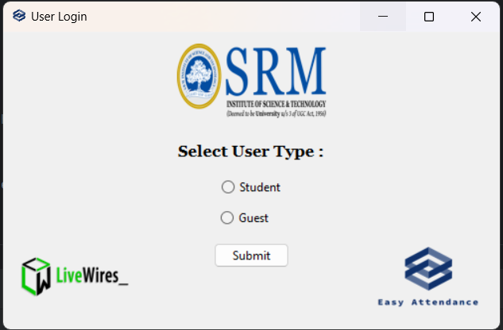

1. If Student, he has to **Enter his Full Register number** like RA2232241010096 and Click Submit.

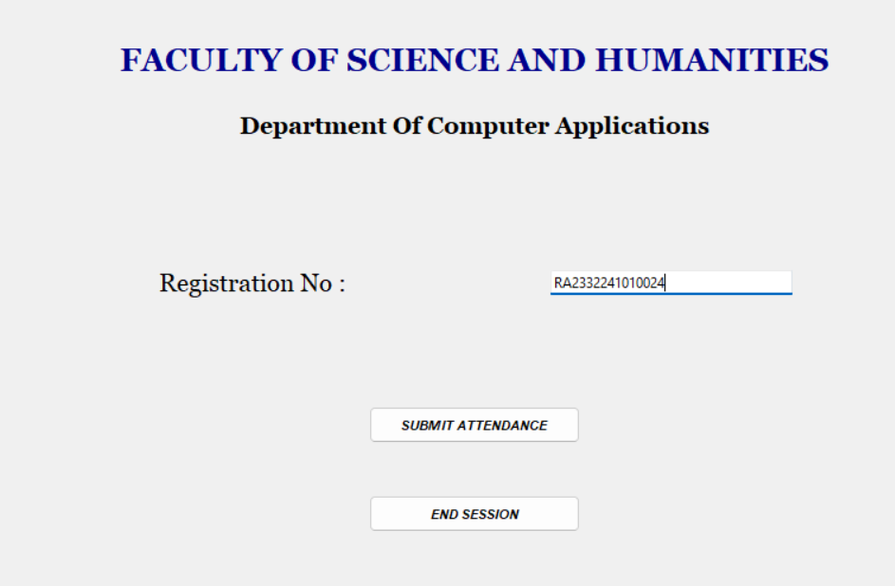

1. 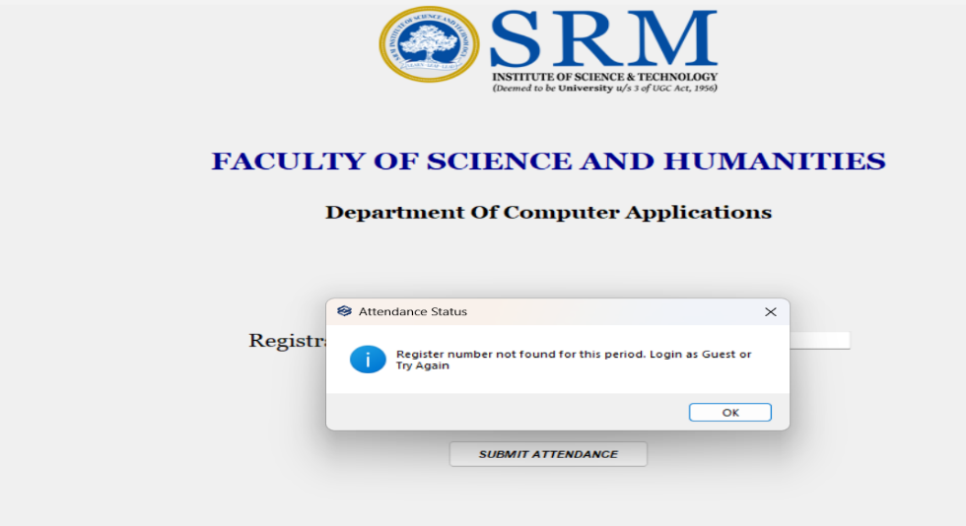**If register number not found**, it will pop up a message like, register number not found for this period. Login as Guest. and then it will again start the student or staff UI
2. 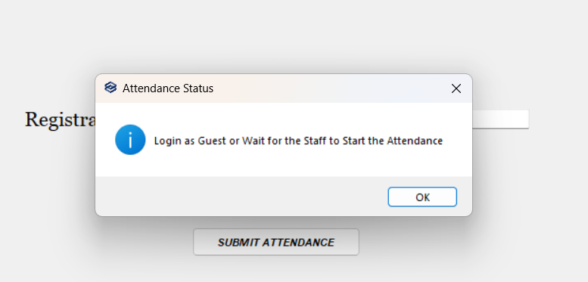If the student tries to **enter attendance before the staff select their subject and class**, we get a pop up to Login as guest or wait for the staff to start the attendance.
3. If **everything is fine**, then **the attendance would be uploaded** and a pop up will be displayed

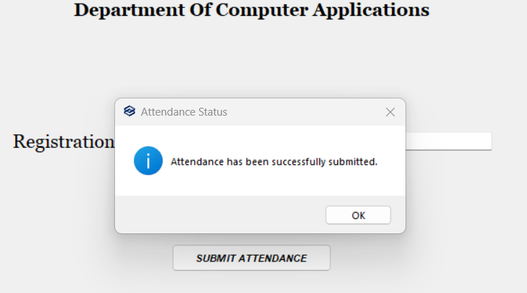

1. 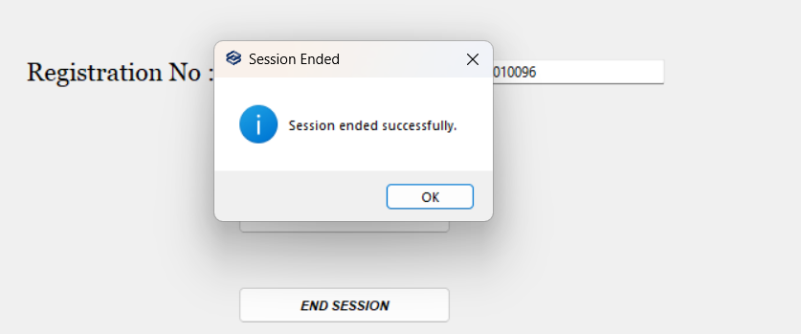To End Session Click End session button
2. **With Register number we will get the details**: -
   * 1. Ug or PG
     2. Course using course id
     3. Joining year
     4. Name from excel
     5. Academic year
     6. Semester
3. The student attendance Ui will **start automatically when ever the system is started**.
4. And it is scheduled to **automatically pop up at the start of every period**.

**Guest Login**

1. Guest has to **enter their Id and Submit it.**
2. It will be **stored in an excel** called Guest Login in admin system:

* Id
* Time
* Date
* System name

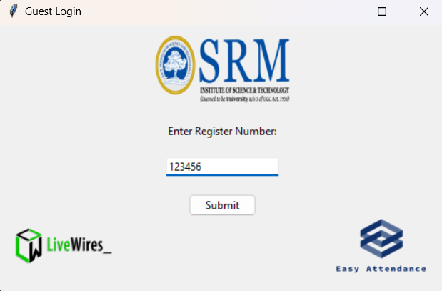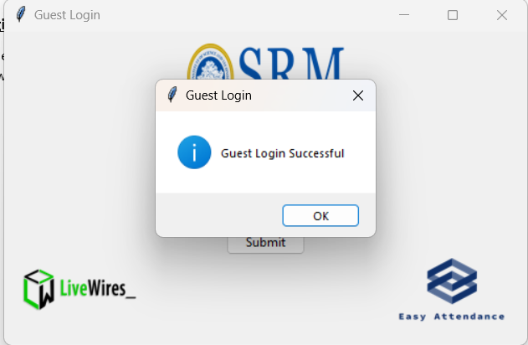

**Attendance Excel sheet**

1. Per day new Excel file will be created with name of current date.
2. Each excel will have 9 sheets named according to each hour, like HOUR 1, HOUR 2 and so on.
3. Each sheet will contain: -

* Name
* Register number
* Course
* Year
* Semester
* Subject
* Staff
* System name

1. **No redundancy** - With register number we will avoid the redundancy
2. System name to **avoid multiple responses from one system**

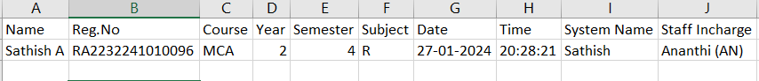**Lab room with staff data Excel**

1. It contains the staff details who handle in particular lab
2. It contains the details of:
   * 1. Name
     2. Subjects handled in that lab
     3. 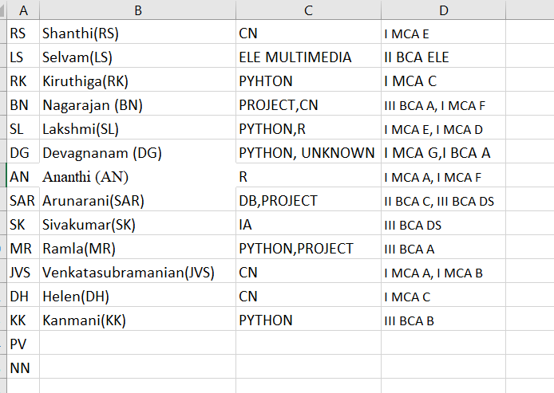Classes handled in that lab

**Student Details Excel**

1. Excel name is **Student Details**
2. It contains 8 sheets as of now with Course name and year like I MCA, II MCA , I BCA ,II BCA D
3. It contains the details of students:
   * 1. Register Number
     2. 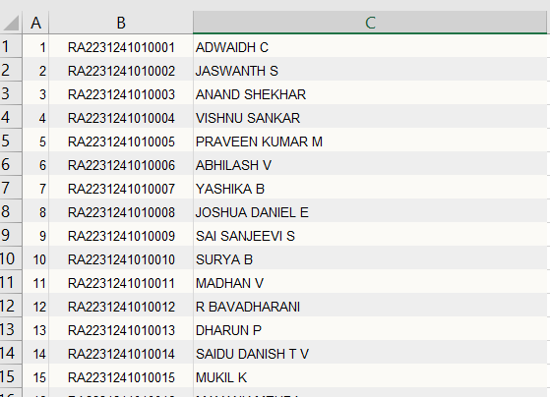Name

**Guest Login Excel**

1. It will be **stored in an excel** called Guest Login in admin system:

* Id
* Time
* Date
* 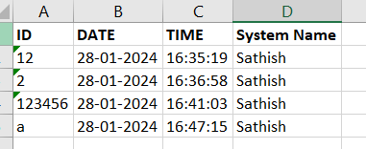System name